[All Unity Asset Store Assets](http://u3d.as/9cs%22%20%5Ct%20%22_blank) | [Linkedin](http://eepurl.com/bK1UCr%22%20%5Ct%20%22_blank) | [Looking for a freelancer?](https://www.hopwork.fr/profile/ganb%22%20%5Ct%20%22_blank) | [Unity Connect](https://connect.unity.com/u/582de6fb090915001fae094a%22%20%5Ct%20%22_blank) | [Facebook](https://facebook.com/appadvisory%22%20%5Ct%20%22_blank) | [Twitter](https://twitter.com/AppAdvisory%22%20%5Ct%20%22_blank) |  [Youtube](https://www.youtube.com/channel/UC5cMgK5r_rzTiarF-So3Rtg?spfreload=5%22%20%5Ct%20%22_blank) | [Website](http://app-advisory.com/%22%20%5Ct%20%22_blank) |[Newsletter](http://eepurl.com/bK1UCr%22%20%5Ct%20%22_blank) | [Contact](https://appadvisory.zendesk.com/hc/en-us/requests/new%22%20%5Ct%20%22_blank) | [iOS Games](https://itunes.apple.com/developer/id657096670%22%20%5Ct%20%22_blank) | [Android Games](https://play.google.com/store/apps/developer?id=App+Advisory%22%20%5Ct%20%22_blank) | [Amazon Games](https://www.amazon.fr/App-Advisory-Applis-Jeux/s?ie=UTF8&page=1&rh=n:1661654031,k:App%20Advisory%22%20%5Ct%20%22_blank)

Quick start video: <https://youtu.be/Z9Q4NGCQC1o>

ADS INTEGRATION DOCUMENTATION:

Everything is done for you:

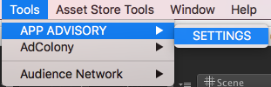

And Select the networks you want (don’t forget to get the SDKs if needed) :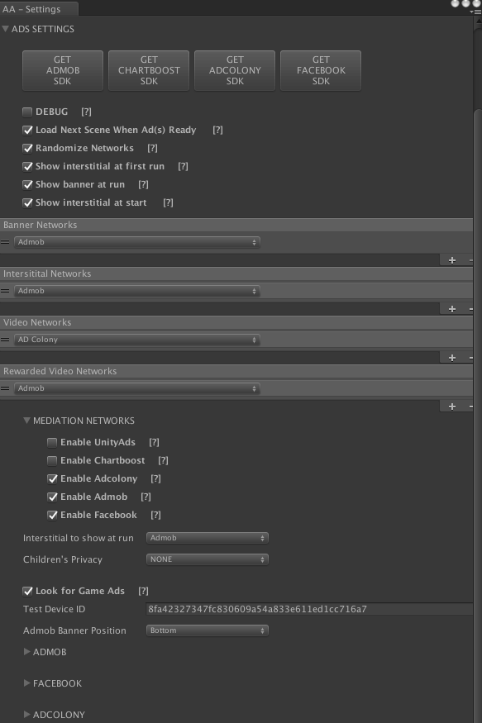

For Unity Ads, please visit my website:

<https://appadvisory.zendesk.com/hc/en-us>

How to manage mediation networks  
to reorganize mediation networks drag the network

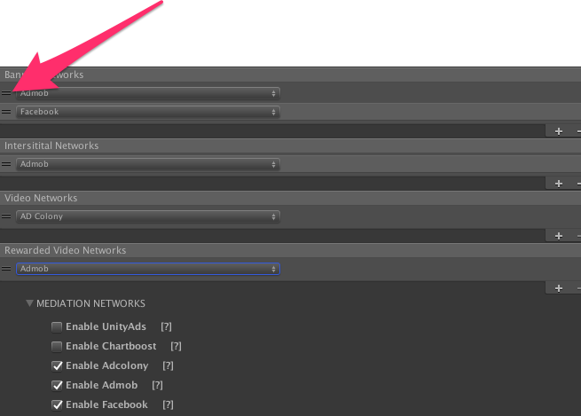

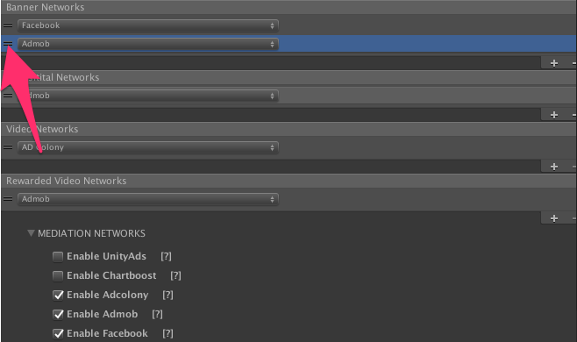

To add or remove networks  
use plus and minus.



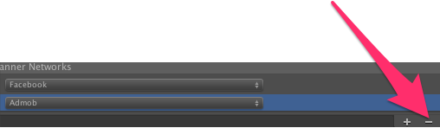

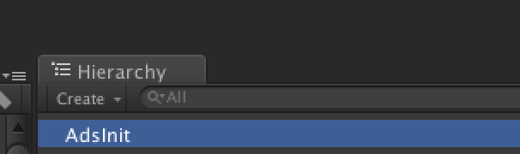

If not, please do a right click on the hierarchy view and:

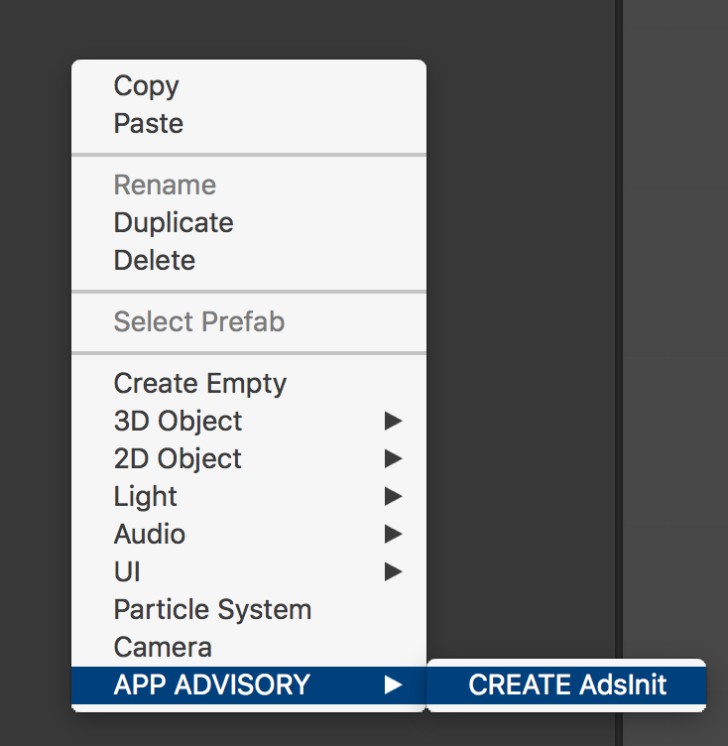

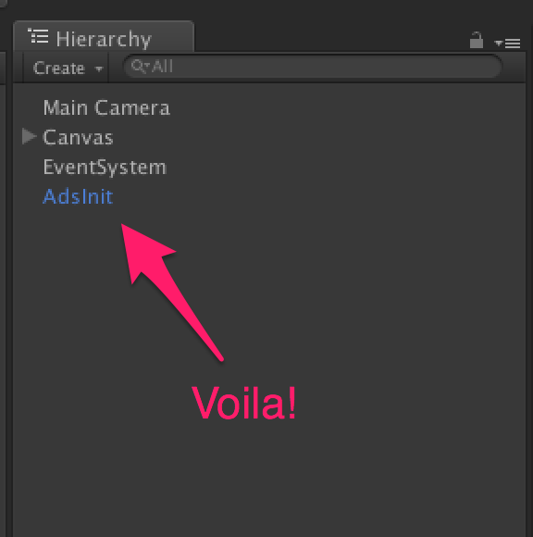

How to check:

* If an interstitial is available ?

*AdsManager.instance.IsReadyInterstitial()*

Return a boolean : true if ready, false if not.

* If a video ad is available ?

*AdsManager.instance.IsReadyVideoAds()*

Return a boolean : true if ready, false if not.

* If a rewarded video is available ?

*AdsManager.instance.IsReadyRewardedVideo()*

Return a boolean : true if ready, false if not.

How to show :

* An interstitial ?

*AdsManager.instance.ShowInterstitial()*

* A video ad?

*AdsManager.instance.ShowVideoAds()*

* A rewarded video?

*AdsManager.instance.ShowRewardedVideo( () => {*

*If(success)*

*{*

*//give a reward to the player*

*}*

*else*

*{*

*//the player do not complete the video*

*}*

*})*

OR

*AdsManager.instance.ShowRewardedVideo(Method) ;*

And the method called is like this:

*Void Method(bool success)*

*{*

*If(success)*

*{*

*//give a reward to the player*

*}*

*else*

*{*

*//the player do not complete the video*

*}*

*}*

**How to add a loading page to load ads before to start the game? Open add settings**



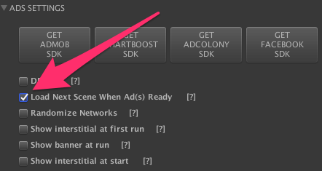

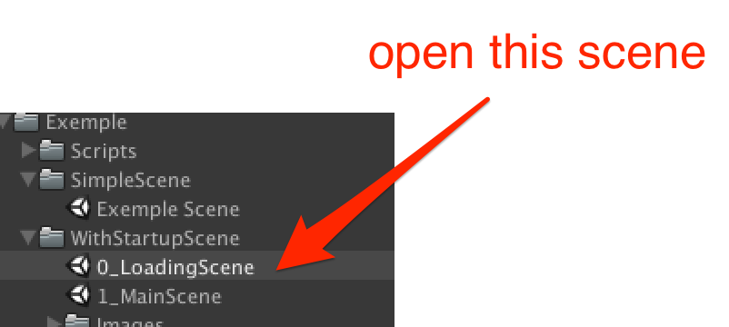

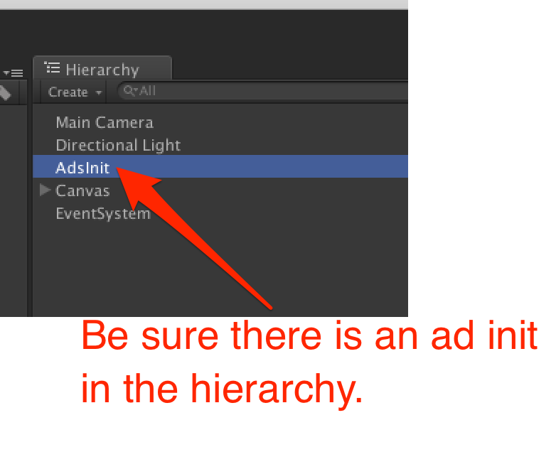

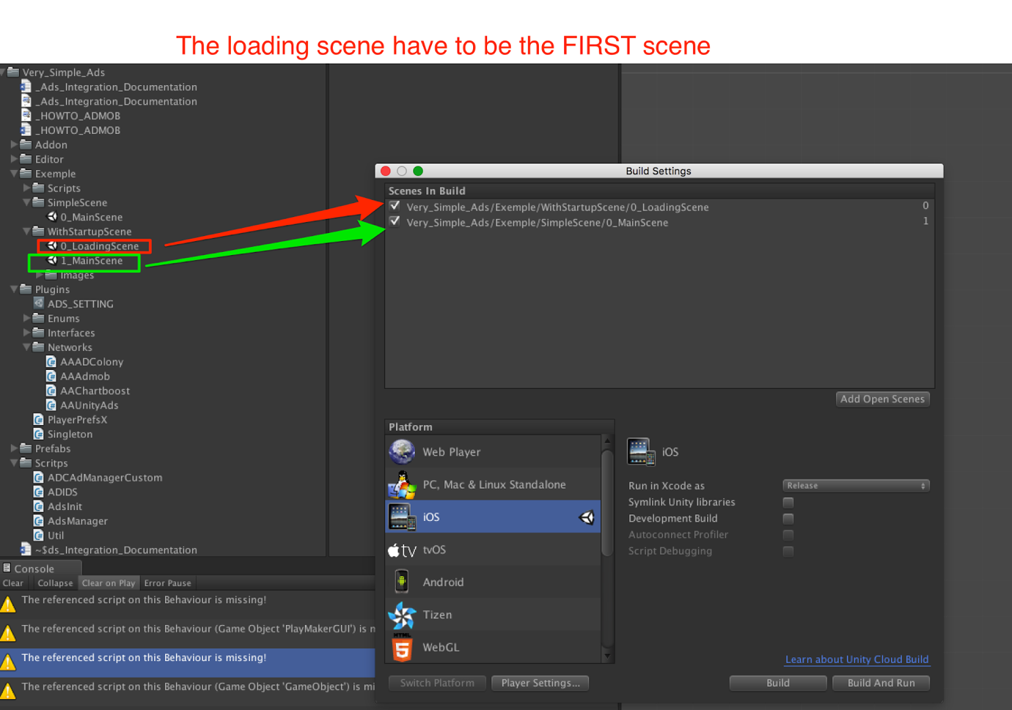

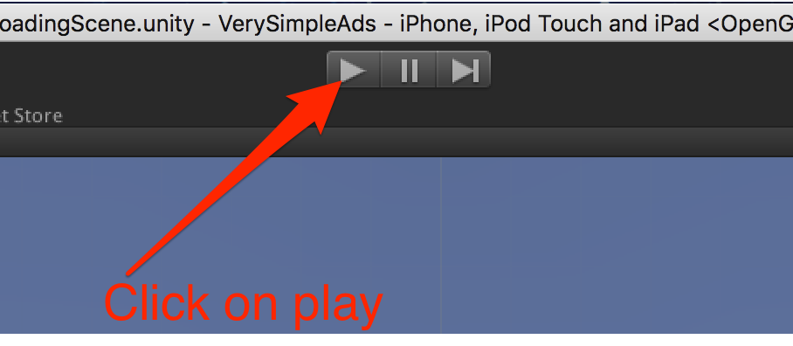

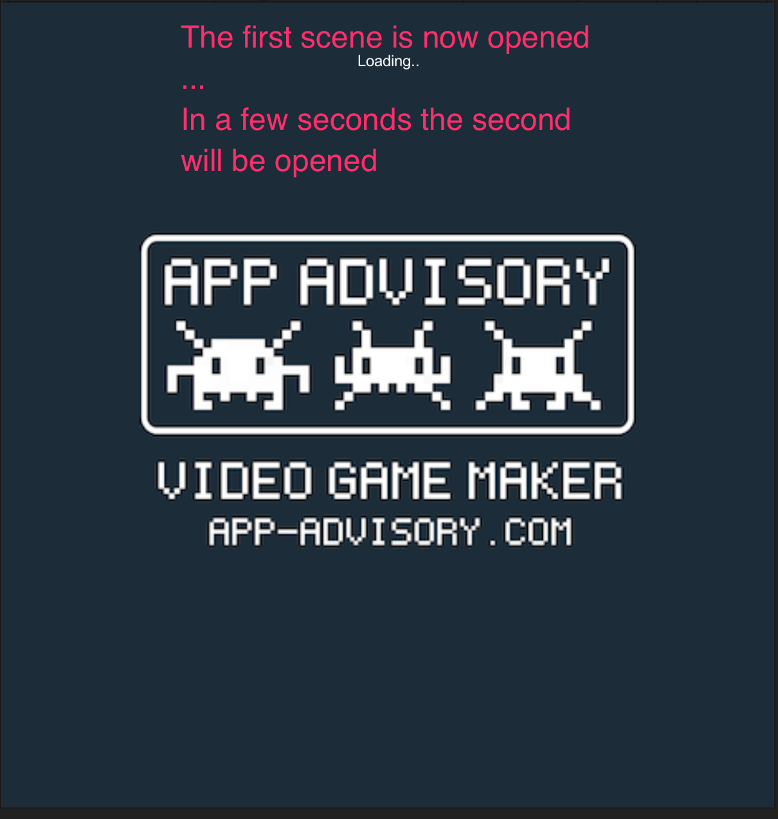

**No-ads system:**

If you want to disable ads use this method :



**Subscribe to events:**

Be notified when static interstitial is opened:

./../../../../../var/folders/3d/_68g_lwn0zb4d4

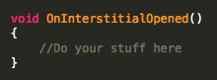

Be notified when static interstitial is closed:

./../../../../../var/folders/3d/_68g_lwn0zb4d4

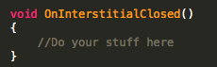

Be notified when video interstitial is opened:

./../../../../../var/folders/3d/_68g_lwn0zb4d4

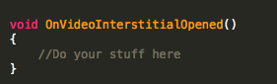

Be notified when video interstitial is closed:

./../../../../../var/folders/3d/_68g_lwn0zb4d4

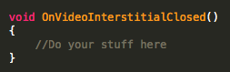

**Frequently Encountered Problem:**

* **Build failure :**

If you activate both Admob and Facebook  Audience Network at the same time you might get this error.  To solve it, you need to delete any duplicated file in the .jar files in the folders Plugins/Android.

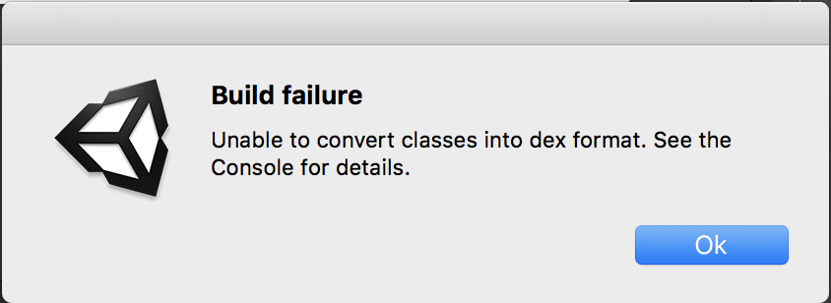

Thanks!

Our other assets: <http://u3d.as/9cs>

Contact: [contact@app-advisory.com](mailto:contact@app-advisory.com)

\*\*\*\*\*\*\*\*\*\*\*\*\*\*\*\*\*\*\*\*\*\*\*\*\*\*\*\*\*\*\*\*\*\*\*\*\*\*\*\*\*\*\*\*\*\*\*\*\*\*\*\*\*\*\*\*\*\*\*\*\*\*\*\*\*\*\*\*\*\*\*\*\*\*\*\*\*\*\*\*\*\*\*\*\*\*\*\*\*\*\*\*\*\*\*\*\*\*\*\*\*\*\*\*\*\*\*\*\*\*\*\*\*\*\*\*\*\*\*\*\*\*\*\*\*\*\*\*\*\*\*\*\*\*\*\*\*\*\*\*\*\*\*\*\*\*\*\*\*\*\*\*\*\*\*\*\*\*\*\*\*\*\*\*\*\*\*\*\*\*\*\*\*\*\*\*\*\*\*\*\*\*\*\*\*\*\*\*\*\*\*\*\*\*\*\*\*\*\*\*\*\*\*\*\*\*\*\*\*\*\*\*\*\*\*\*\*\*\*\*\*\*\*\*\*\*\*\*\*\*\*\*\*\*\*\*\*\*\*\*\*\*\*\*\*\*\*\*\*\*\*\*\*\*\*\*\*\*\*\*\*\*\*\*\*\*\*\*\*\*\*\*\*\*\*\*\*\*\*\*\*\*\*\*\*\*\*\*\*\*\*\*\*\*\*\*\*\*\*\*\*\*\*\*\*\*\*\*\*\*\*\*\*\*\*\*\*\*\*\*\*\*\*\*\*\*\*\*\*\*\*\*\*\*\*\*\*\*\*\*\*\*\*\*\*\*\*\*\*\*\*\*\*\*\*\*\*\*\*\*\*\*\*\*\*\*\*\*\*\*\*\*\*\*\*

For Admob integration (Xcode / Android) =>

* https://developers.google.com/admob/unity/start

For Admob mediation, please have a look here =>

* https://developers.google.com/admob/unity/mediation

\*\*\*\*\*\*\*\*\*\*\*\*\*\*\*\*\*\*\*\*\*\*\*\*\*\*\*\*\*\*\*\*\*\*\*\*\*\*\*\*\*\*\*\*\*\*\*\*\*\*\*\*\*\*\*\*\*\*\*\*\*\*\*\*\*\*\*\*\*\*\*\*\*\*\*\*\*\*\*\*\*\*\*\*\*\*\*\*\*\*\*\*\*\*\*\*\*\*\*\*\*\*\*\*\*\*\*\*\*\*\*\*\*\*\*\*\*\*\*\*\*\*\*\*\*\*\*\*\*\*\*\*\*\*\*\*\*\*\*\*\*\*\*\*\*\*\*\*\*\*\*\*\*\*\*\*\*\*\*\*\*\*\*\*\*\*\*\*\*\*\*\*\*\*\*\*\*\*\*\*\*\*\*\*\*\*\*\*\*\*\*\*\*\*\*\*\*\*\*\*\*\*\*\*\*\*\*\*\*\*\*\*\*\*\*\*\*\*\*\*\*\*\*\*\*\*\*\*\*\*\*\*\*\*\*\*\*\*\*\*\*\*\*\*\*\*\*\*\*\*\*\*\*\*\*\*\*\*\*\*\*\*\*\*\*\*\*\*\*\*\*\*\*\*\*\*\*\*\*\*\*\*\*\*\*\*\*\*\*\*\*\*\*\*\*\*\*\*\*\*\*\*\*\*\*\*\*\*\*\*\*\*\*\*\*\*\*\*\*\*\*\*\*\*\*\*\*\*\*\*\*\*\*\*\*\*\*\*\*\*\*\*\*\*\*\*\*\*\*\*\*\*\*\*\*\*\*\*\*\*\*\*\*\*\*\*\*\*\*\*\*\*\*\*\*

OLD VERSION (under 1.1.3)

ADS INTEGRATION DOCUMENTATION :

Everything is done for you :



And Select the networks you want (don’t forget to get the SDKs if needed) :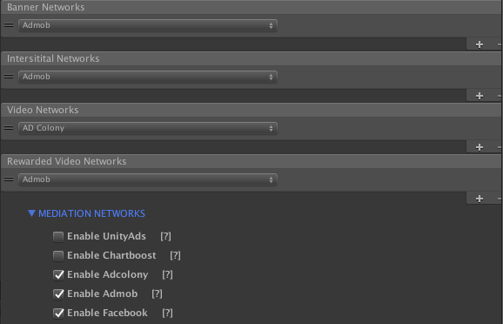

For Unity Ads, please visit my website :

<https://appadvisory.zendesk.com/hc/en-us>

You should have a GameObject named « AdsInit » in the hierarchy view :



If not, please do a right click on the hierarchy view and :





How to check :

* If an interstitial is available ?

*AdsManager.instance.IsReadyInterstitial()*

Return a boolean : true if ready, false if not.

* If a video ad is available ?

*AdsManager.instance.IsReadyVideoAds()*

Return a boolean : true if ready, false if not.

* If a rewarded video is available ?

*AdsManager.instance.IsReadyRewardedVideo()*

Return a boolean : true if ready, false if not.

How to show :

* An interstitial ?

*AdsManager.instance.ShowInterstitial()*

* A video ad?

*AdsManager.instance.ShowVideoAds()*

* A rewarded video?

*AdsManager.instance.ShowRewardedVideo( () => {*

*If(success)*

*{*

*//give a reward to the player*

*}*

*else*

*{*

*//the player do not complete the video*

*}*

*})*

OR

*AdsManager.instance.ShowRewardedVideo(Method) ;*

And the method called is like this :

*Void Method(bool success)*

*{*

*If(success)*

*{*

*//give a reward to the player*

*}*

*else*

*{*

*//the player do not complete the video*

*}*

*}*

**How to add a loading page to load ads before to start the game ?**

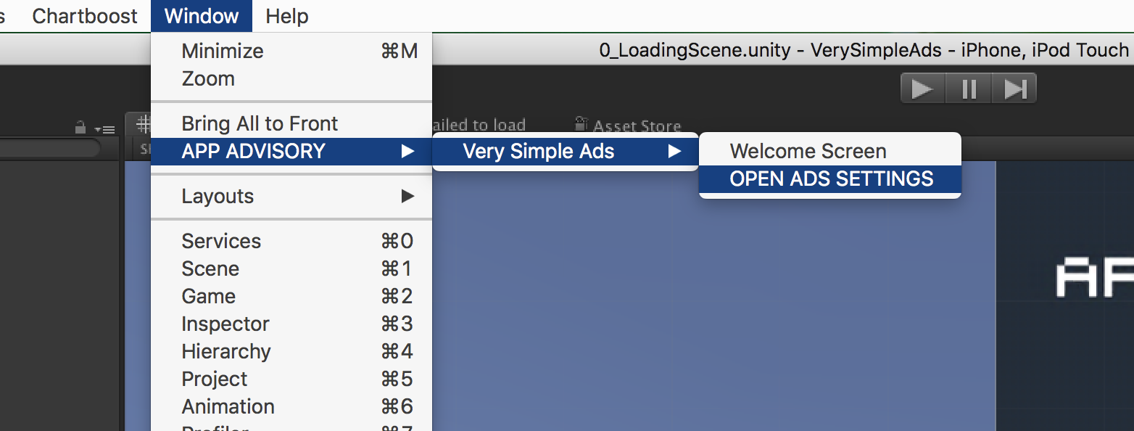











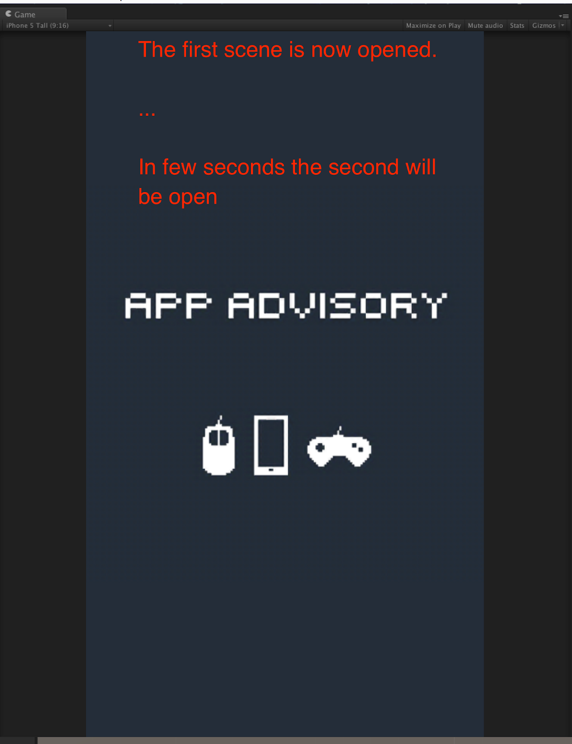

**Subscribe to events :**

Be notified when static interstitial is opened :

./../../../../../var/folders/3d/_68g_lwn0zb4d4



Be notified when static interstitial is closed:

./../../../../../var/folders/3d/_68g_lwn0zb4d4



Be notified when video interstitial is opened:

./../../../../../var/folders/3d/_68g_lwn0zb4d4



Be notified when video interstitial is closed:

./../../../../../var/folders/3d/_68g_lwn0zb4d4



Thanks !

Our other assets : <http://u3d.as/9cs>

Contact : [contact@app-advisory.com](mailto:contact@app-advisory.com)

---

1/ Import Very Simple Ads

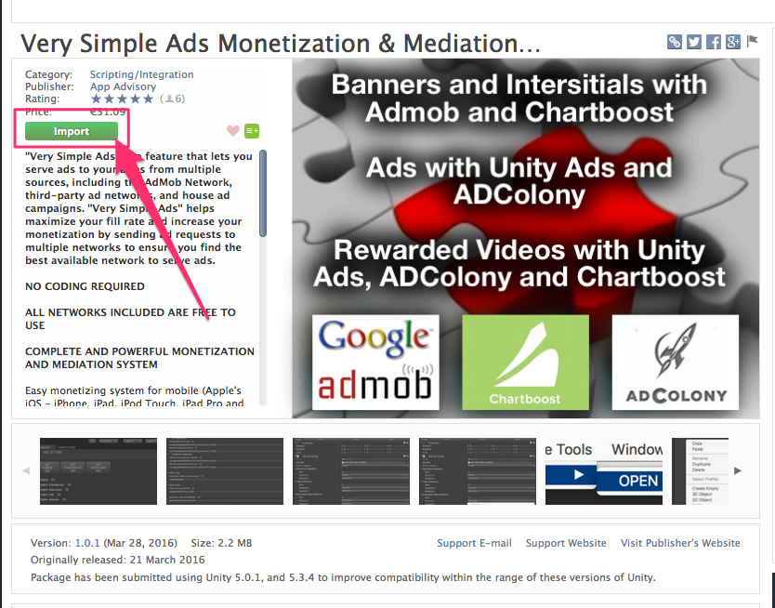

Then :

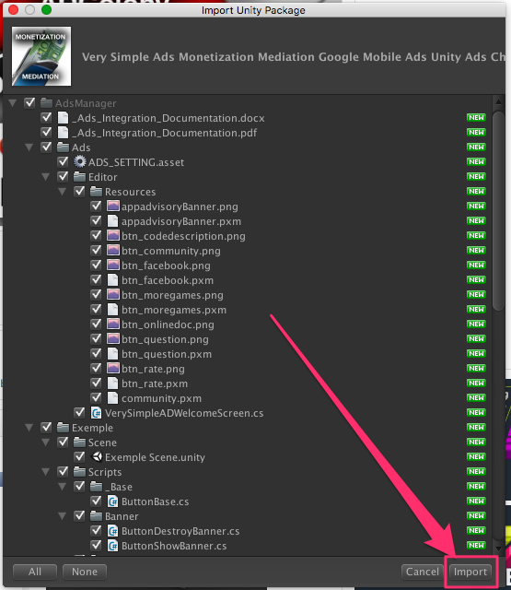

2/ Open the Ads Settings Editor :

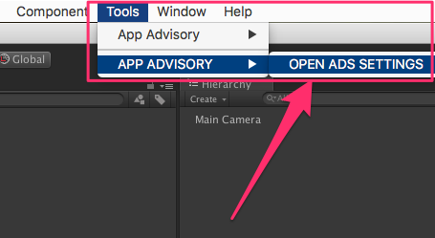

You should see :

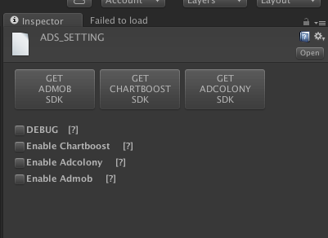

3/ Switch on a mobile platform :

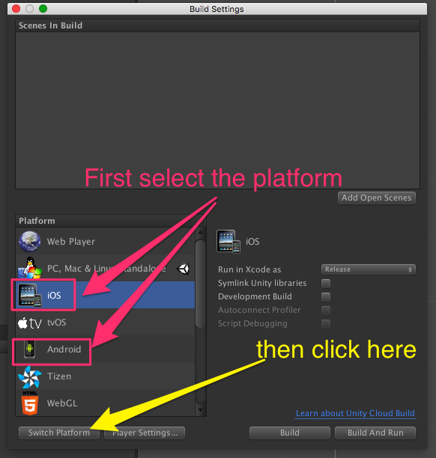

**ADMOB :**

1/ Get the SDK :

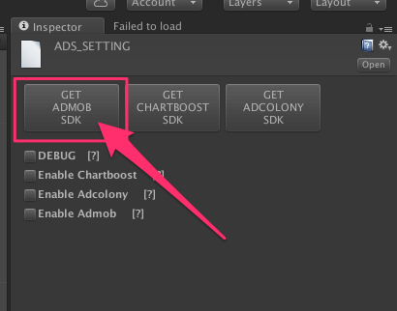

2/ Grab the last release :

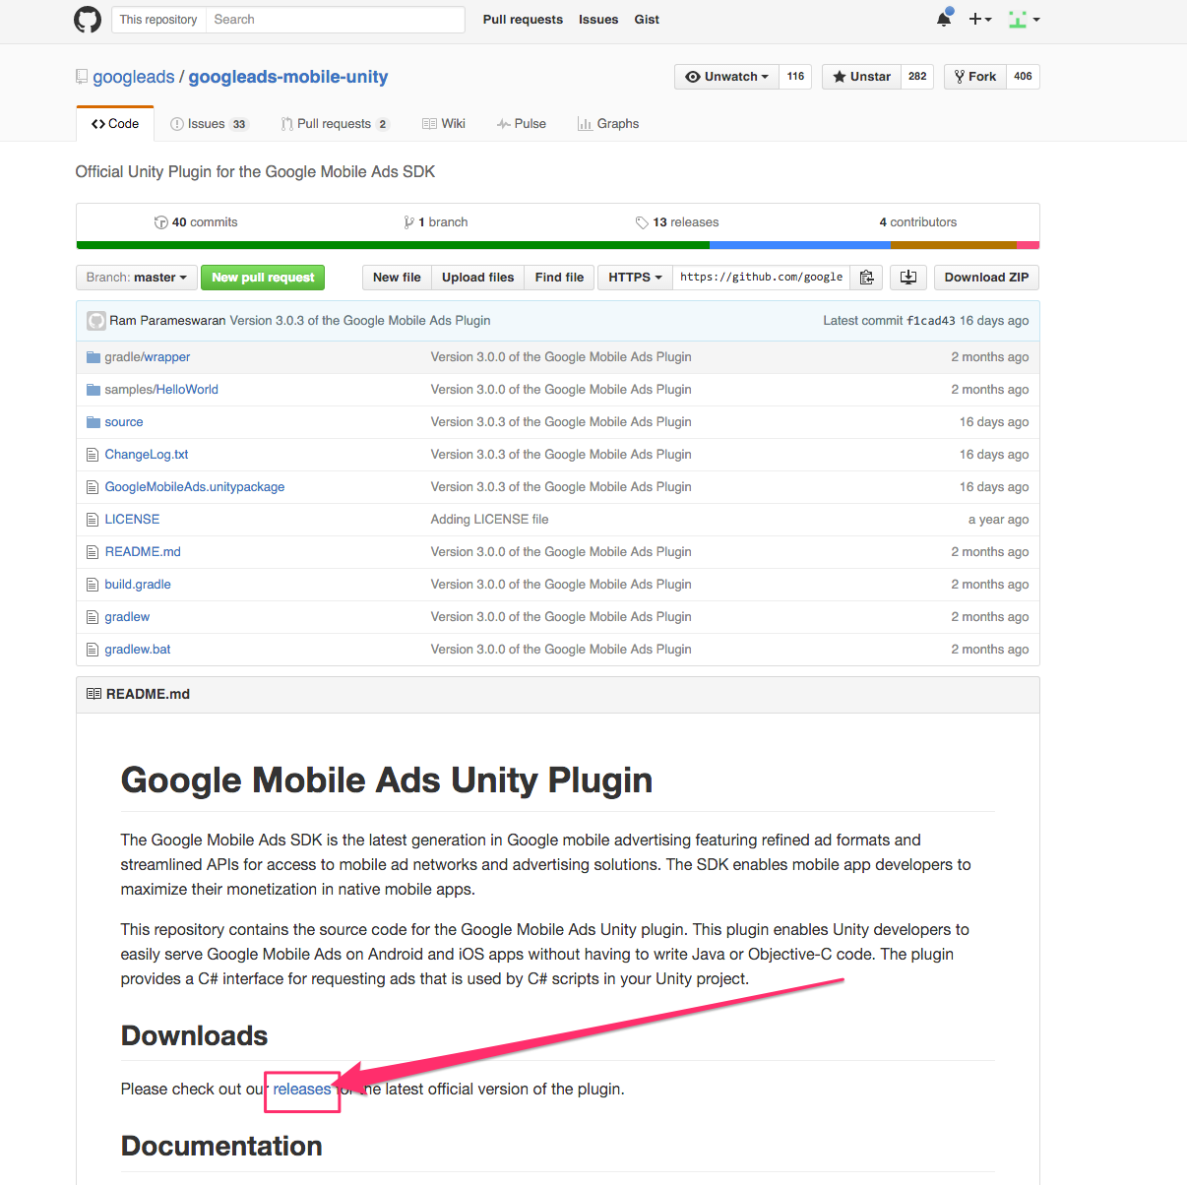

3/ And download the SDK

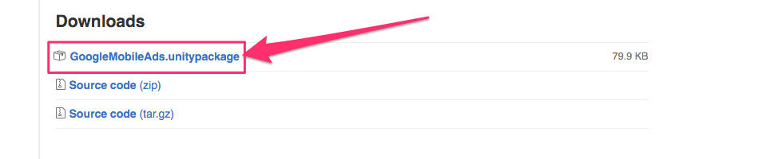

4/ Open the downloaded file (double click on it) and import it to your project :

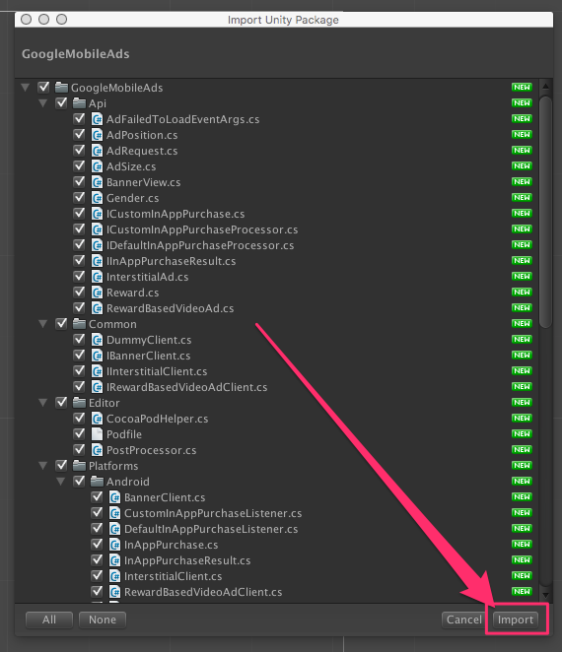

5/ Open th Ads Settings Editor again :



6/ Check the box to enable admob

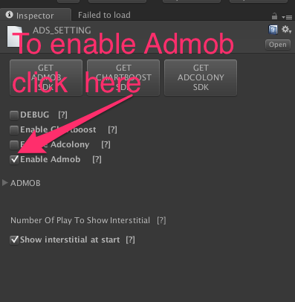

7/ Now you can enter your ids :

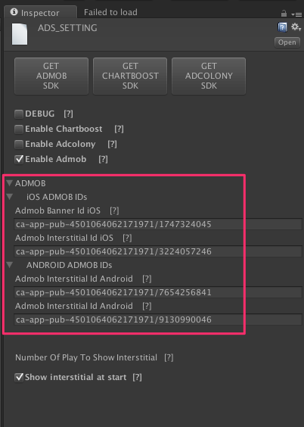

8/ You have to add the AdsInit to your scene now ! To do that :

* Right click on an empty space on the hierarchy (= not on a game object) :

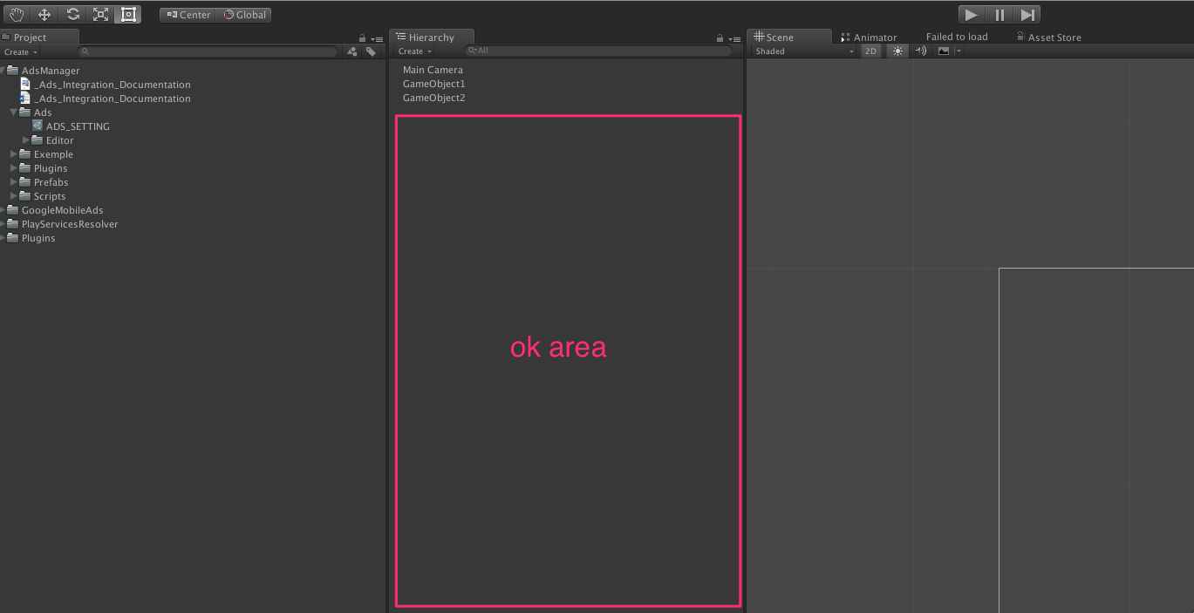

* And then select « CREATE AdsInit » :

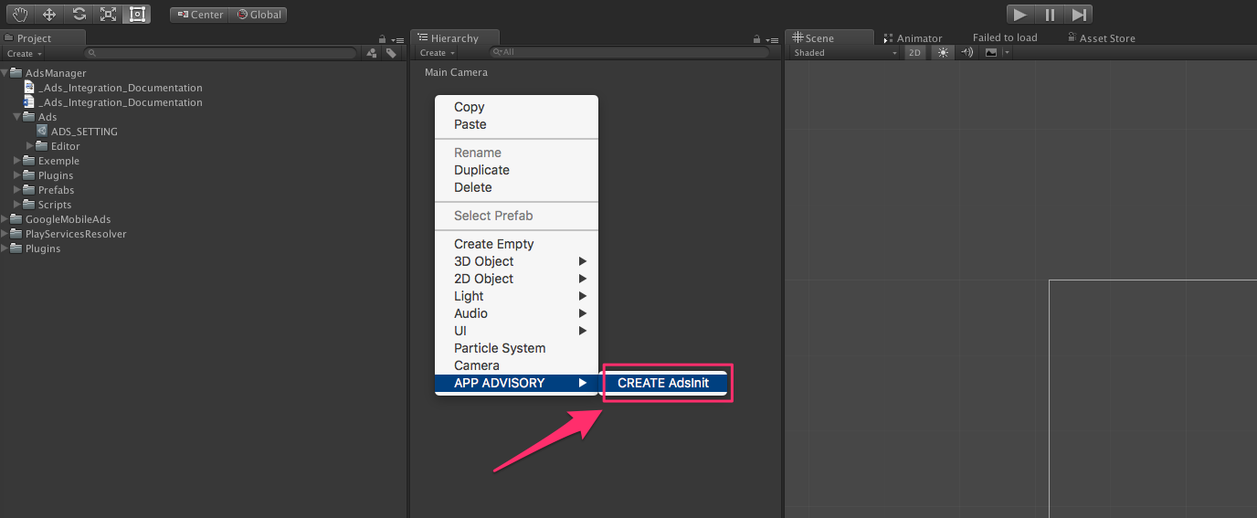

* And voilà !

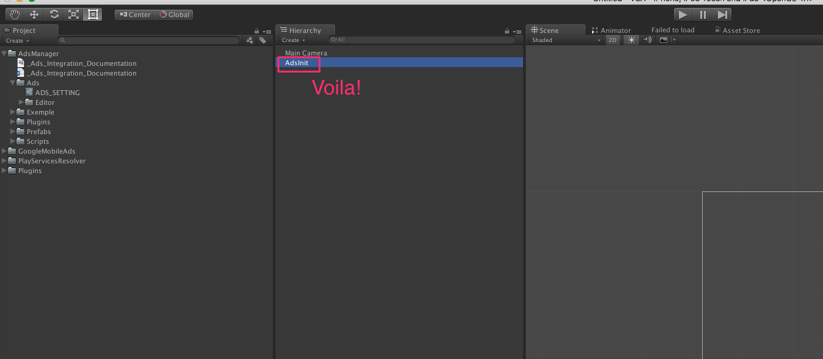

9/ Set banner, interstitial etc …

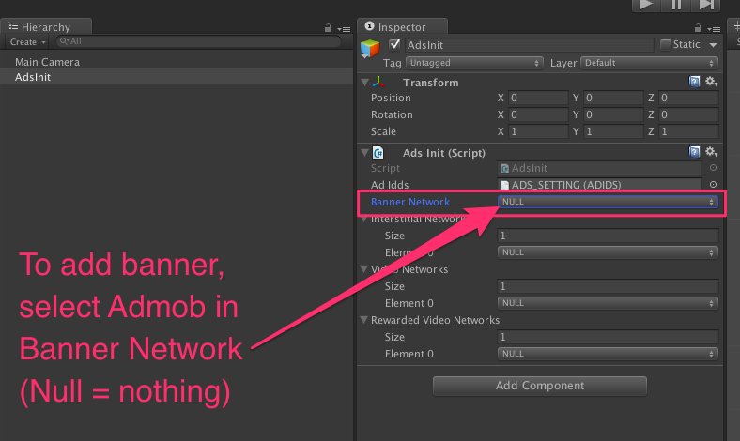

Like this :

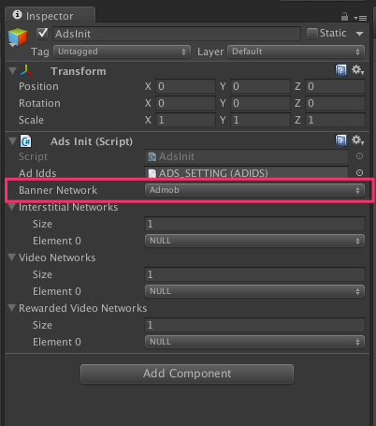

Same things for interstitial etc…

TO SHOW INTERSTITIAL :

Import AppAdvisory.ads :

./../../var/folders/3d/_68g_lwn0zb4d4rm9spylzt

Call this method :

./../../var/folders/3d/_68g_lwn0zb4d4rm9spylzt

TO SHOW REWARDED VIDEO :

Import AppAdvisory.ads :

./../../var/folders/3d/_68g_lwn0zb4d4rm9spylzt

Call this method :

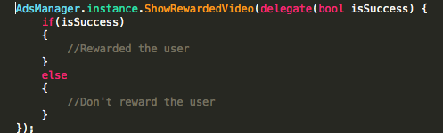

Or like this :

./../../var/folders/3d/_68g_lwn0zb4d4rm9spylzt

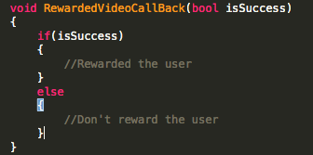

\*\*\*\*\*\*\*\*\*\*\*\*\*\*\*\*\*\*\*\*\*\*\*\*\*\*\*\*\*\*\*\*\*\*\*\*\*\*\*\*\*\*\*\*\*\*\*\*\*\*\*\*\*\*\*\*\*\*\*\*\*\*\*\*\*\*\*\*\*\*\*\*

**For OLD VERSION OF ADMOB SDK for iOS ONLY**

ON IOS :

Build on iOS your project, then you have to import manually the Admob SDK to XCode.

For that, please downlaod the Admob SDK :

By clicking here

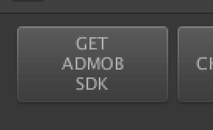

Or on this link :

<https://github.com/googleads/googleads-mobile-unity/releases>

Then find this file :

./../../../../../var/folders/3d/_68g_lwn0zb4d4

And drag and drop it in XCode :

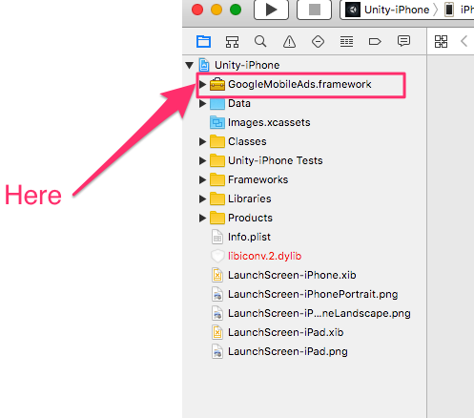

TIPS :

Sometimes, when you build again your project, and you chose « appen », you will have error on XCode.

To fix this :

* Select the Admob SDK :

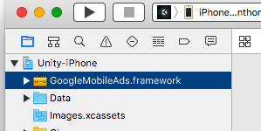

And uncheck and check again this box :

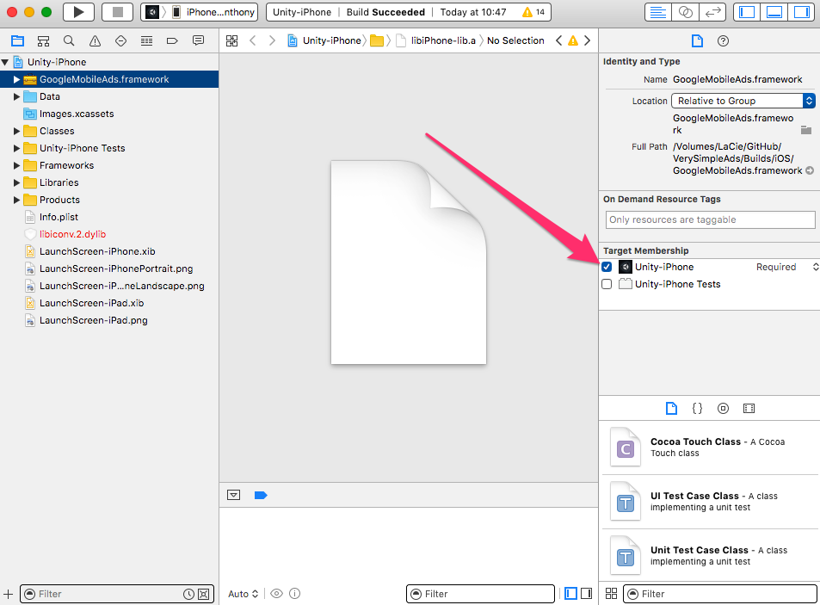

* Do the same thing with this file :

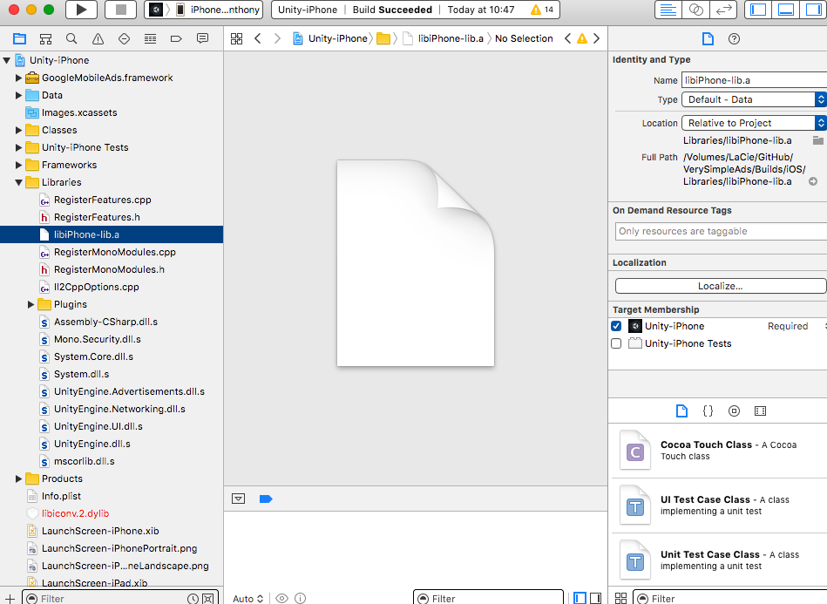

\*\*\*\*\*\*\*\*\*\*\*\*\*\*\*\*\*\*\*\*\*\*\*\*\*\*\*\*\*\*\*\*\*\*\*\*\*\*\*\*\*\*\*\*\*\*\*\*\*\*\*\*\*\*\*\*

[All Unity Asset Store Assets](http://u3d.as/9cs%22%20%5Ct%20%22_blank) | [Linkedin](http://eepurl.com/bK1UCr%22%20%5Ct%20%22_blank) | [Looking for a freelancer?](https://www.hopwork.fr/profile/ganb%22%20%5Ct%20%22_blank) | [Unity Connect](https://connect.unity.com/u/582de6fb090915001fae094a%22%20%5Ct%20%22_blank) | [Facebook](https://facebook.com/appadvisory%22%20%5Ct%20%22_blank) | [Twitter](https://twitter.com/AppAdvisory%22%20%5Ct%20%22_blank) |  [Youtube](https://www.youtube.com/channel/UC5cMgK5r_rzTiarF-So3Rtg?spfreload=5%22%20%5Ct%20%22_blank) | [Website](http://app-advisory.com/%22%20%5Ct%20%22_blank) |[Newsletter](http://eepurl.com/bK1UCr%22%20%5Ct%20%22_blank) | [Contact](https://appadvisory.zendesk.com/hc/en-us/requests/new%22%20%5Ct%20%22_blank) | [iOS Games](https://itunes.apple.com/developer/id657096670%22%20%5Ct%20%22_blank) | [Android Games](https://play.google.com/store/apps/developer?id=App+Advisory%22%20%5Ct%20%22_blank) | [Amazon Games](https://www.amazon.fr/App-Advisory-Applis-Jeux/s?ie=UTF8&page=1&rh=n:1661654031,k:App%20Advisory%22%20%5Ct%20%22_blank)